Maths Activities – Wednesday 14th July 2021
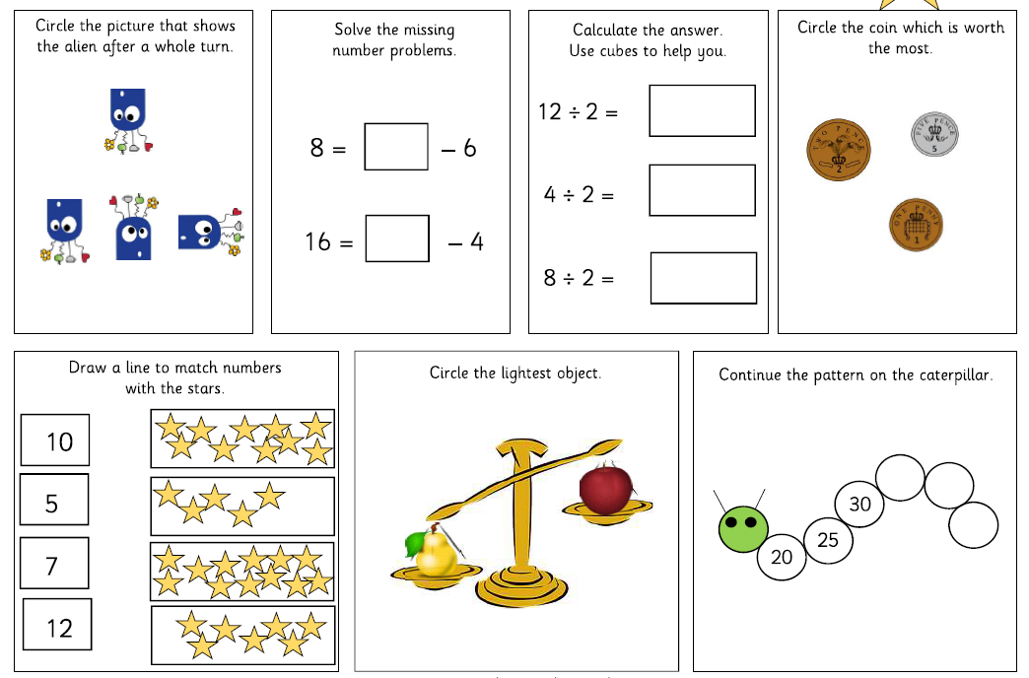
Miss Campey’s 3 star challenge- If you are feeling confident then have a go!
