Maths Activities - Monday 12th July 2021
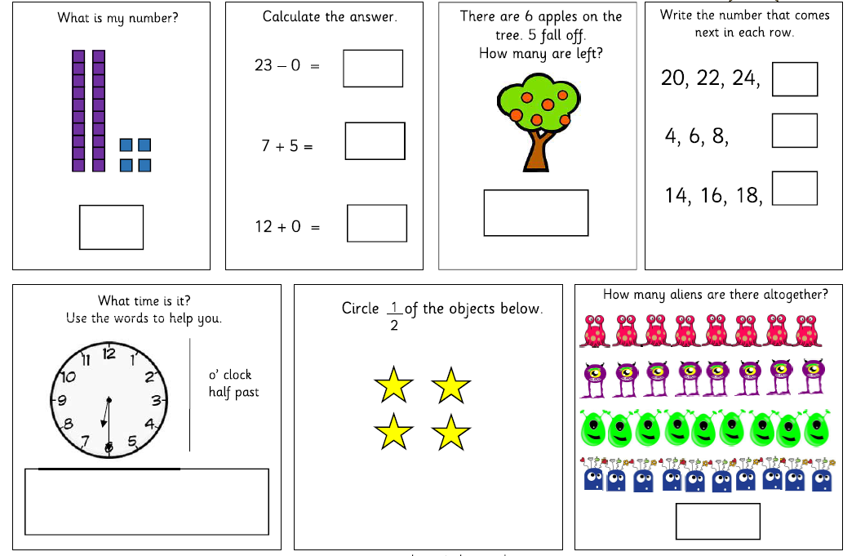
Miss Campey’s 3 star challenge- If you are feeling very confident have a go!

